SANITARY PADS DISTRIBUTION AND MENTORSHIP GRANT REPORT

PERSON RESPONSIBLE FOR SUBMITTING REPORT | Benter Akinyi Ndeda | Project Co-Ordinator

AMOUNT RECEIVED IN KENYA SHILLINGS | 261,998/- | FROM GLOBAL FOOTSTEPS(UK)
NAME OF IMPLEMENTORS | Aniga Women Initiative | Community Based Org
PLANNED ACTIVITIES | - Mapping of schools and identifying the needy pupils for purpose of sanitary Pads distribution.  - Ordering and purchasing the sanitary pads  - Receiving and distribution of pads to schools
LOCATION | West Seme Ward-Kisumu County
REPORTING PERIOD | 1st Jan -30th Jan 2022
Date of submission | 28th Jan, 2022

- Background

Female students face great challenges in terms of hygiene and sanitation. For girls who are menstruating, these problems compound the difficulties posed by the inability to afford sanitary towels as well as cultural taboos around menstruation. As a result, many girls miss on average four days of school every month which is over a month in a year, meaning they fall behind in class and sometimes even drop out of school altogether. This is an added challenge to the already existing problems that lead to the high dropout rate of female students in primary and secondary schools. The main problems faced by women and girls are: • The expense of commercial sanitary pads; • Absenteeism where girls stay at home rather than attending school when menstruating; • Unhygienic ways to dry menstrual materials; • Inadequate waste disposal facilities; • Lack of privacy for changing menstrual materials; • Leakage from poor-quality protection materials; • The lack of resources for washing such as soap; • Limited education about the facts of menstruation; • Limited access to counseling and guidance; • Fear caused by cultural myths; • Embarrassment and low self-esteem; • And the unsupportive attitudes of some me

The objective of the project:

The overriding objective of the project is to ensure that Girls in Kisumu County will not have to miss school simply because they are menstruating. Other objectives are to ensure that: • To improve school attendance among girls between the ages of 10 and 17 years in primary & Secondary schools; • To increase access to vulnerable adolescent girls with sanitary towels and comprehensive menstrual hygiene management knowledge and risk awareness of HIV&AIDS among in-school and out of school girls between the ages 10 to 17 years; • To increase the self-esteem of needy girls between ages 10 to 17 years; • And to document lessons learned and scale-up options documented.

In this regard, Global Footsteps Granted Aniga CBO KSH 261,000 accomplish the above Objectives.

  - Progress and Achievements
ITEMS REQUIRED | PIECE | AMOUNT SPEN T IN KSH. | TARGETED NUMBER OF SCH | NUMBERS OF PUPILS REACHED | CHALLENGES FACED | RECOMENDATIONS
2050 pcs | @102 | 209,000 | 10 | 670 | High number of vulnerable girls as compared to the supply  We has to reduce the number of supply so that each girls could get a supply for 3 months. | Increase of supply or at least 2-3 times supply in a year.  There is a great complain by the boy child and they feel neglected, proposing to include buys innerwear to boost their self-esteem as most walk around on tattered short and being laughed at by girls. Most of them have opted to drop out of school instead.
 |  |  |  |  | There is a great challenge of disposing the used pads in schools, since the pads fill up the pit latrines in a very speedy time. This poses a very great challenge to the health of pupils’ population. Most schools can not afford to put up new toilets block termly or yearly. | Each school to have locally made incinerator to help in pads disposal and to reduce the speeding up of filling toilets this will reduce diarrheal diseases in pupils and increase the school enrolment and keep pupils in schools.
Transportation by supplier to Aniga office | 1 | 15000 |  |  | For a bigger bulk purchase, this has to be done in Nairobi.
Transportations to selected schools | 3days  @5000 | 15000 |  |  | Most road terrains to some schools made the team not get there in time.  Time taken in engagement with girls makes us do several trips hence the 3 days
Mentorship engagement | 3@ 2000x 3days | 18,000 |  |  | The girls had a lot of challenges and were very open to discussion bearing in mind the current situation regarding mental challenges in youths. | Very encouraging moments that should be encouraged and boys should be involved
Documentation |  | 4000
TOTAL |  | 261,000

Some of the photos of sanitary distribution
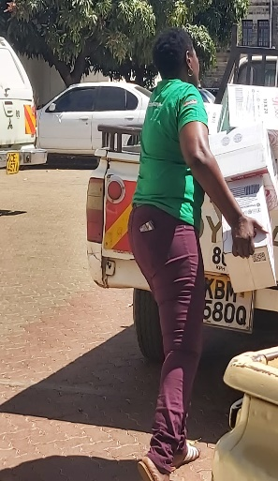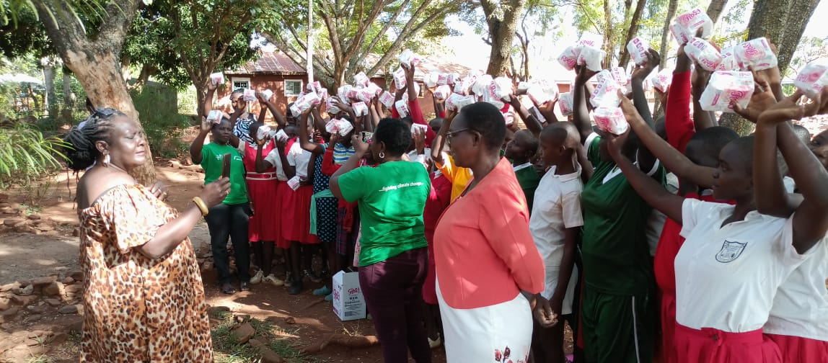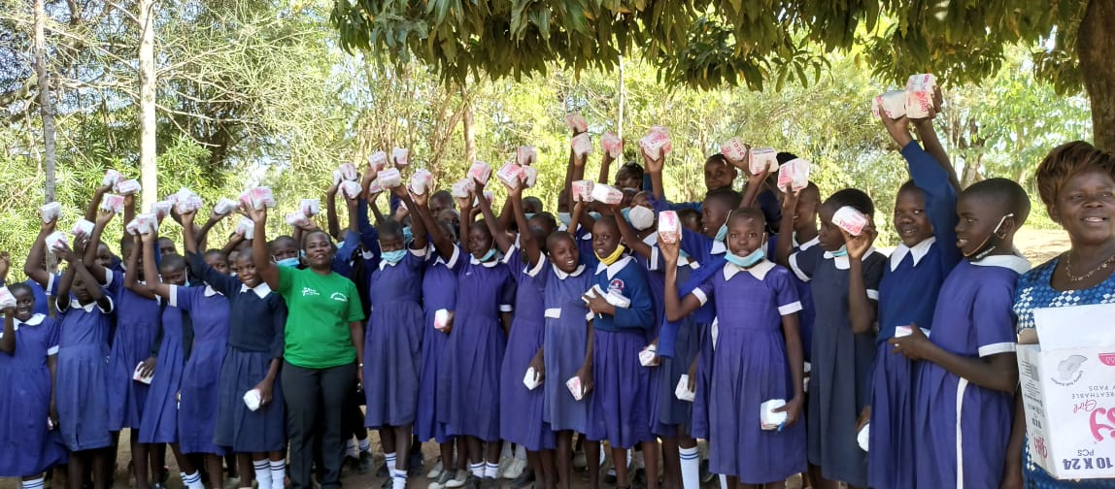

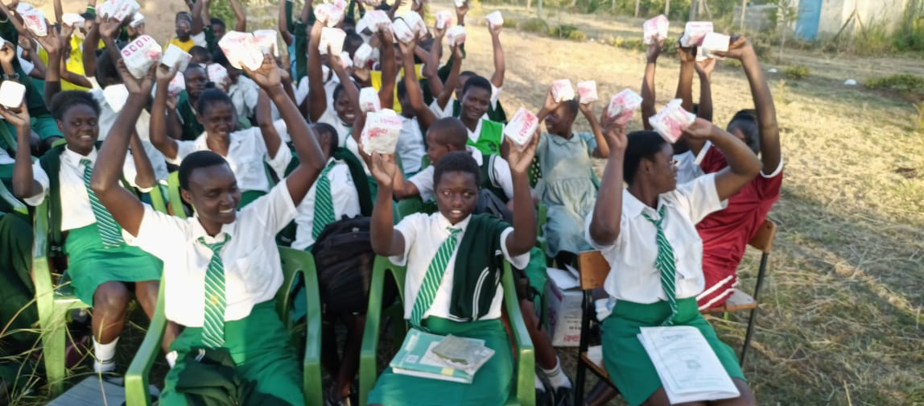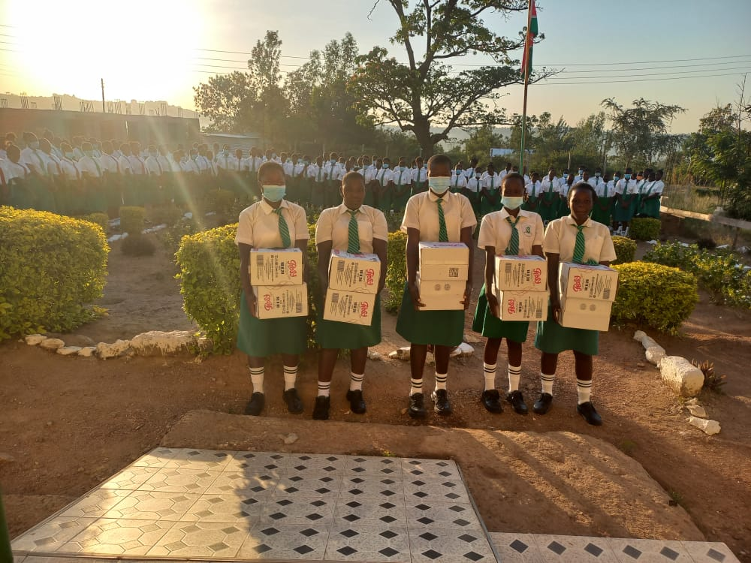

NB: On behalf of Aniga CBO we are very grateful to the opportunity the Global Footstep Foundation has continually accorded us through funding to be responsible and change makers in our community. We continue to be grateful to our global Foundation Partner for always being ready to support us through grants which has continued to enable us implement more of the relevant projects that will lift the living standard of our community.
THANK YOU!!!!!

